Introduction

This write-up refers to the SAORI machine.If you require support, please open a ticket in the support channel on the Discord server.

Nmap Scan:
As a first step, we need to determine which services are running in the background and which ports are open. Therefore, we will use a tool called nmap.
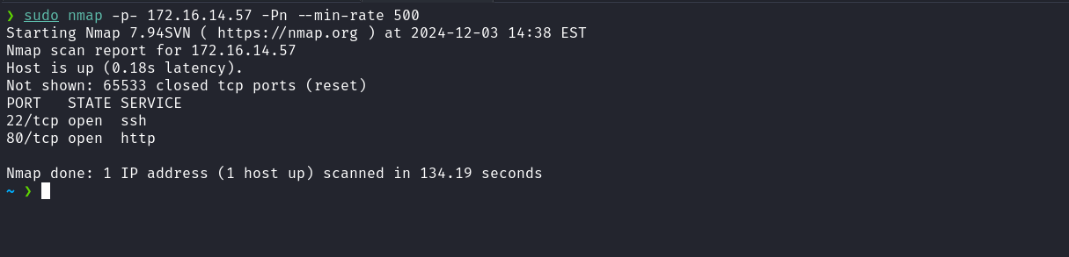
We observed the presence of port 80 hosting a web service and port 22 corresponding to SSH. When accessing port 80 of the web service, a redirection occurs to the domain saori.hc.
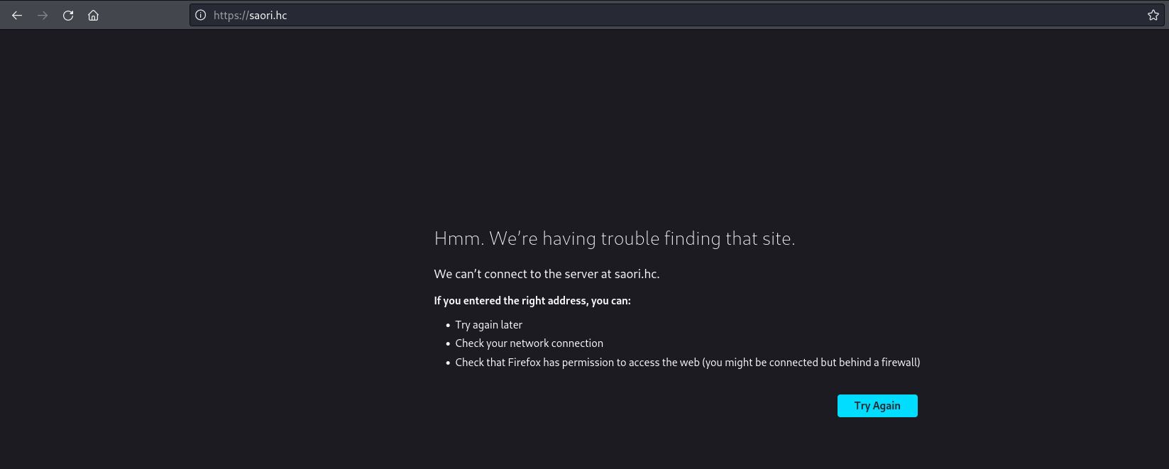
To resolve this, it is necessary to map the IP address to the domain name by adding an entry to the hosts file, as demonstrated in the image below.
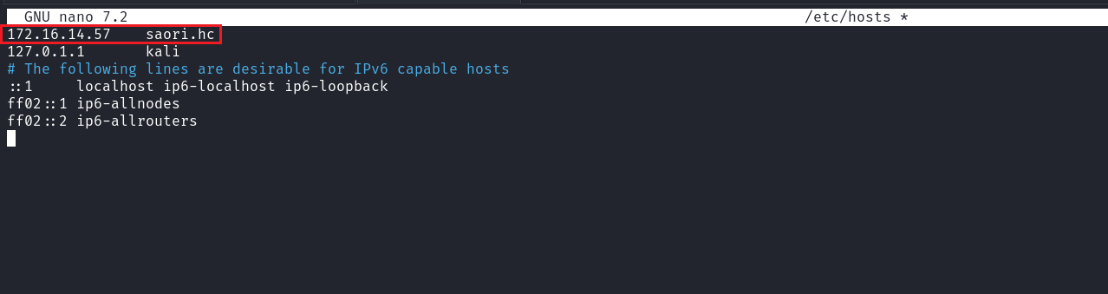
After accessing the application again, we identified that it is a blog. Analyzing the navigation bar (navbar), we observed a button that allows downloading a client.

After downloading the client, we verified that it is an ELF 64-bit binary. When executing it, we observed that the binary apparently performs an HTTP request to download a resource, but the operation fails.
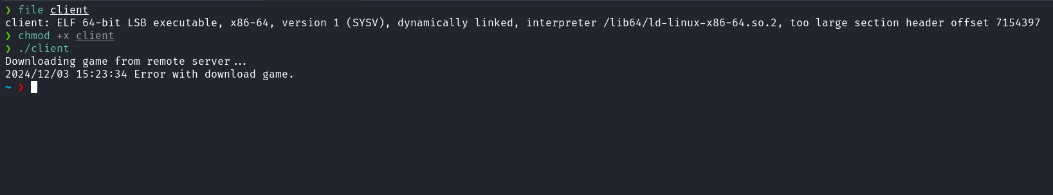
Knowing that the binary apparently performs an HTTP request, we can use Wireshark to capture and analyze the network traffic generated during the execution of the binary.
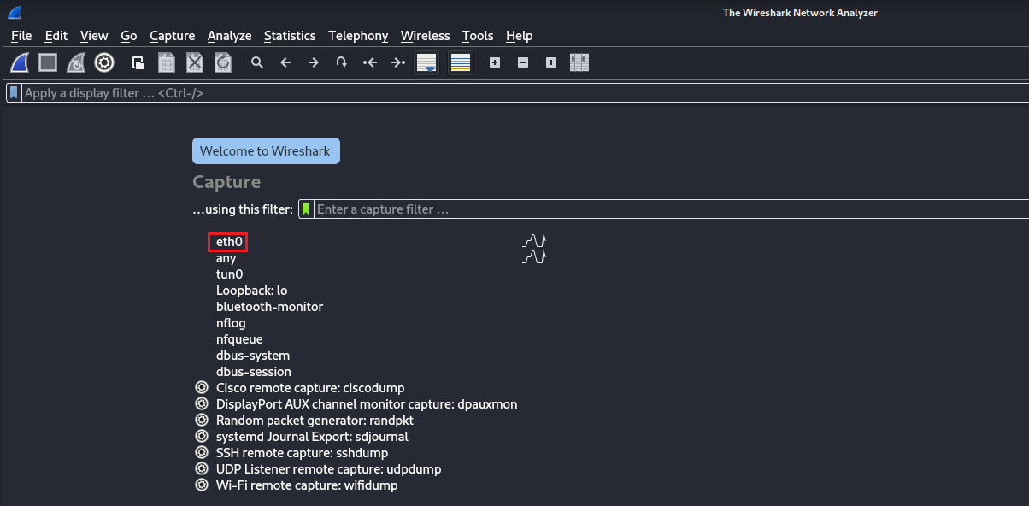
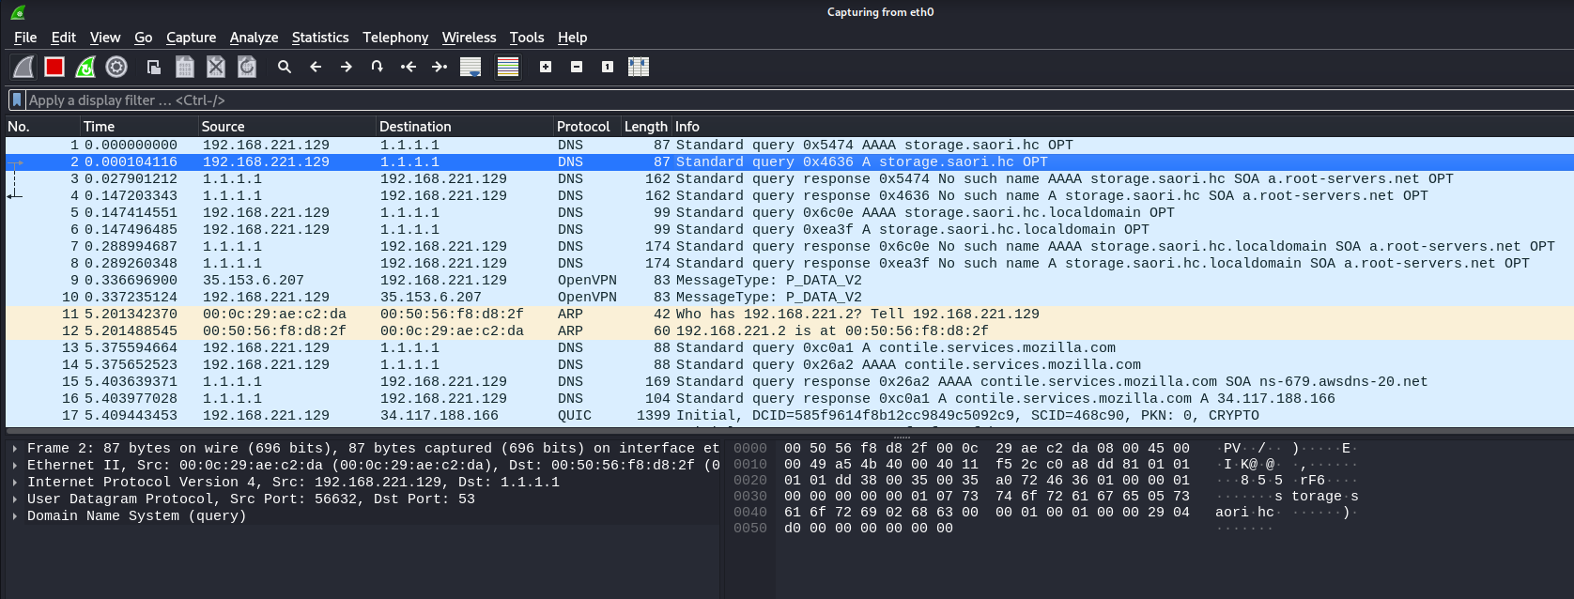
When analyzing the traffic, we identified that the client attempts to connect to the subdomain storage.saori.hc. To allow this connection, we add the subdomain to the /etc/hosts file.
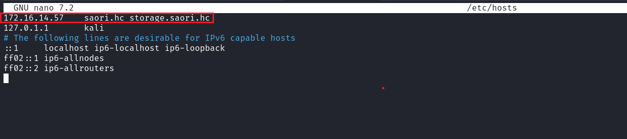
After executing the client binary again and analyzing the traffic, we observed a GET request to the endpoint /game.sfc. In the request header, we identified the presence of Basic Authentication (Basic Auth).
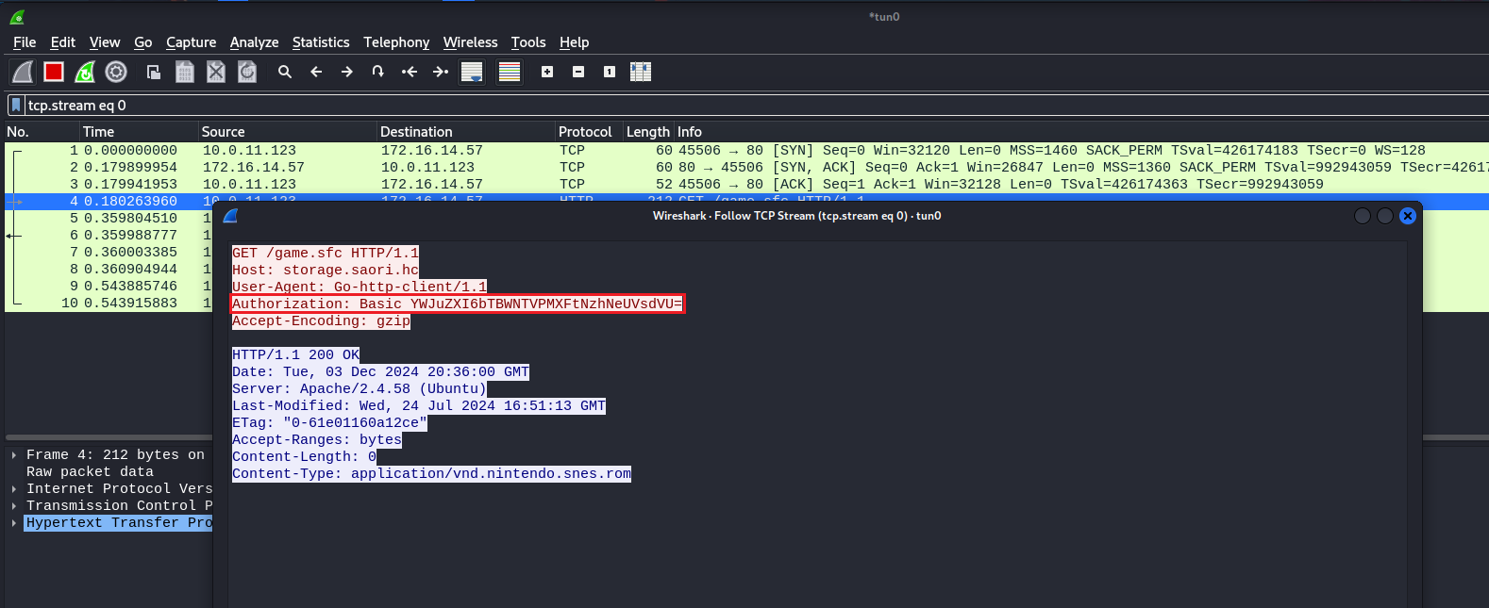
After decoding the Base64 value present in the basic authentication header, we obtained the credentials. We can use them to access the server via SSH.
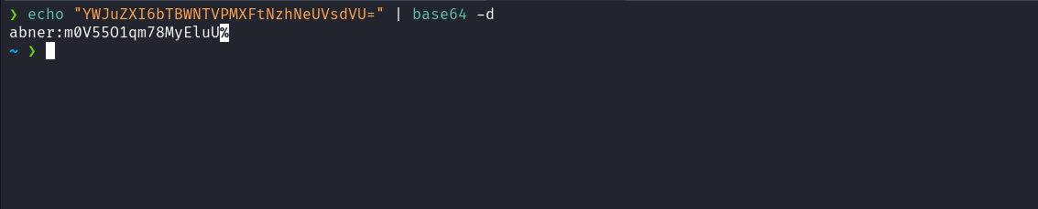

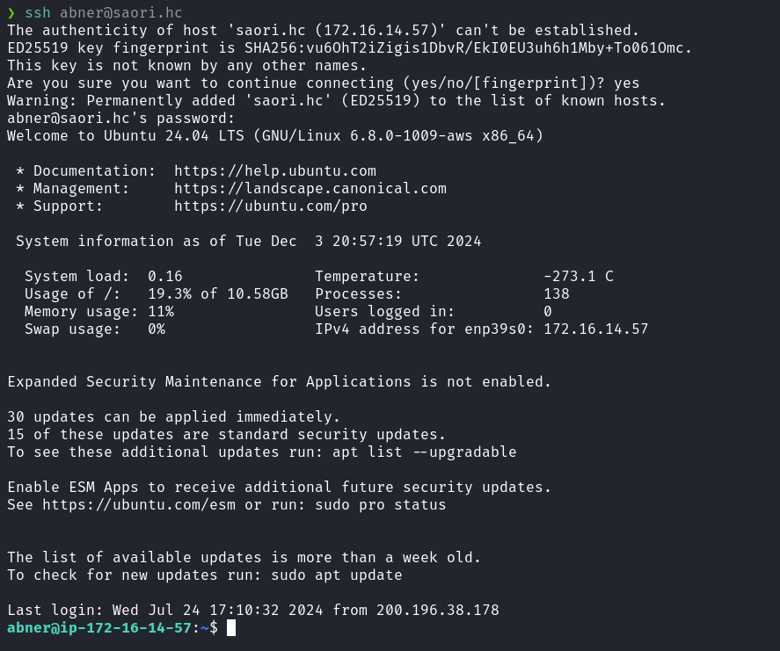
On the home directory of the user abner, we can obtain our first flag.
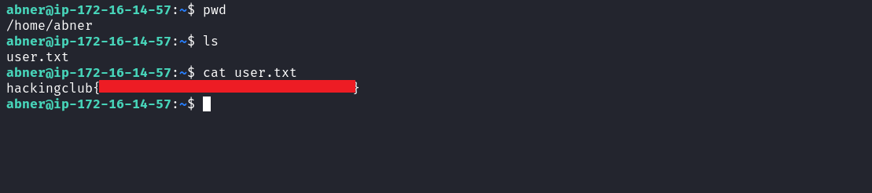

When executing the command sudo -l, we verified that we have permission to execute Ghostscript with root privileges without the need to provide a password. Another relevant detail is the use of the wildcard character /root/*, which indicates a possible path traversal vulnerability. Additionally, when executing gs --help, we identified that the installed version of Ghostscript is 10.03.0.
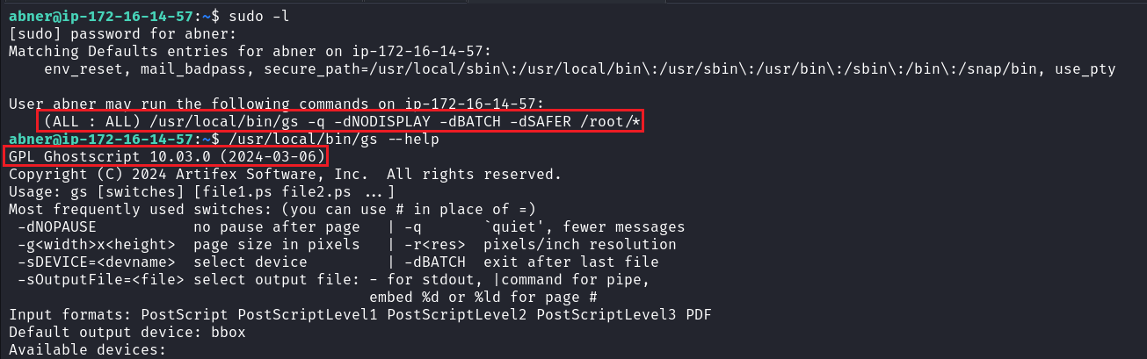
After researching vulnerabilities in Ghostscript version 10.03.0, we identified CVE-2024-29510, which describes a format string exploitation vulnerability. For more information and technical details about this CVE, see the link below:
https://codeanlabs.com/wp-content/uploads/2024/06/CVE-2024-29510_poc_calc.eps
In the provided link, we found a proof of concept (PoC) that, by default, executes gnome-calculator. We can modify the PoC code to execute the command id and save the output to the file id.txt. This will allow us to validate whether it is possible to execute commands within the exploit context.
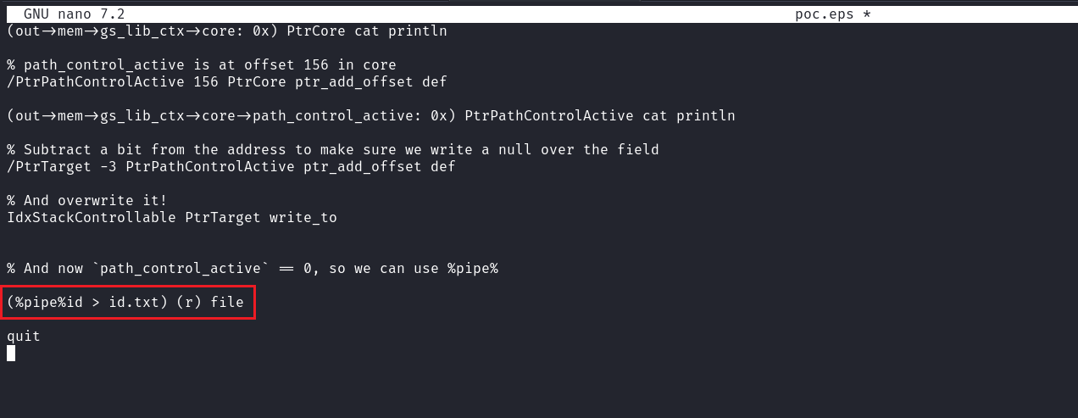
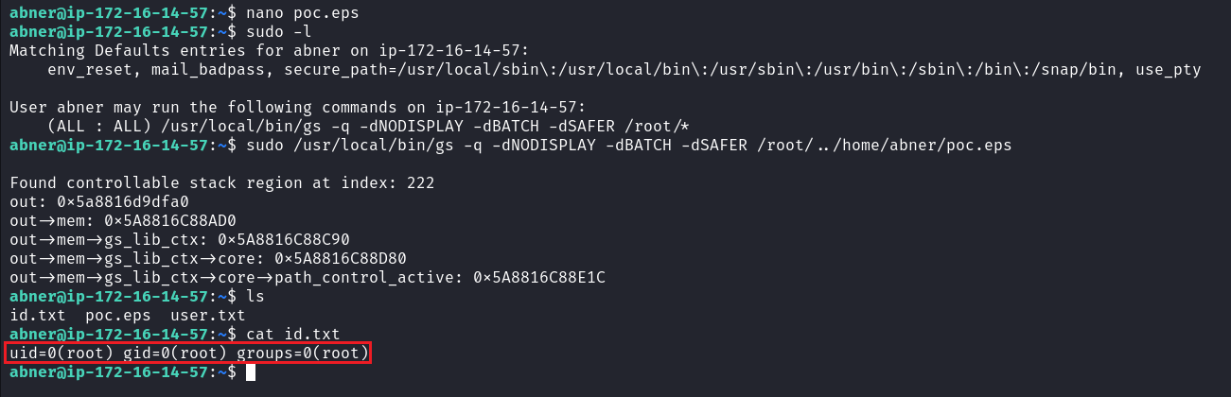
We can observe that the exploit worked correctly, as the file id.txt was created and, when reading it, we found the output of the id command.
It is worth noting that, to execute the poc.eps file located in our home directory, we need to exploit the path traversal vulnerability to manipulate the path.
Knowing this, we can modify the command to chmod u+s /bin/bash, which will configure the bash binary with the SUID permission. Thus, by executing bash -p, we will obtain a privileged shell. With this, we can retrieve the final flag.
